**PROFILE**

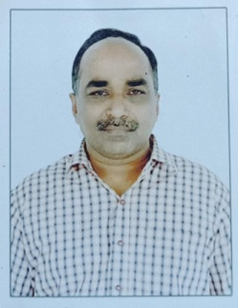

1. Name: K. Viswanadha Raju
2. Designation: Assistant Professor, Department of Management Studies
3. Date of Birth: 07-08-1969
4. Educational Qualifications: MBA., M.Phil.,
5. Teaching Experience: 19 Years
6. Research Experience: Nil
7. Dissertation/Thesis (M.Phil.)Title:**:**  Performance Evaluation of Prime Ministers Rojagar Yojana with

Reference to West Godhavari Dist.

1. No. of Research Publications: Nil
2. No. of Books Published: Nil
3. No. of Major/Minor Research projects: Nil
4. Title of Minor Research Project: Nil
5. No. of International Conference Attended: Nil
6. No. of National conferences Attended: Nil
7. No. of Papers Presented at the Seminars/Conferences: Nil
8. Refresher Courses/Orientation Programmes/Training Programmes Attended: Nil
9. Vidwaan Score: Nil
10. Address: Flat No.502, BVR Towers Brodi Peta, Palakol W.G.Dt AP
11. Email Id: visvanadhsvkp@gmail.com
12. Contact No: +91 9849517977